**Seasoned Saints Reflections**

**Issue 1: 4 July 2020**

**Nancy Spencer-Smith**

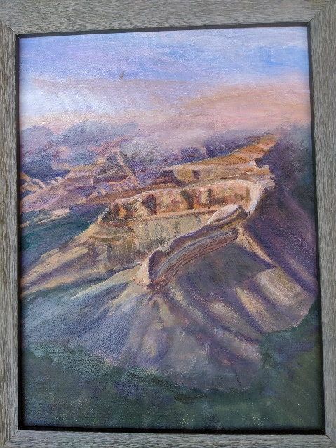Since March I have been taking an online year long course offered by the Tucson Art Academy and featuring Matt Smith as instructor.  Although I started oil painting as a young girl during my summers in NH, I never found the time to return to it until last year when I joined our Monday art group here in Rio Verde. Matt's course has been a God-send and given me the opportunity to explore Arizona, be mentally outdoors in nature, and to slowly learn how to express myself with paint. Discipline and perseverance seem to be my new friends, and when I stray

they come find me!

This painting takes as its inspiration a photograph found in Arizona Highways Special Scenic Collection of the Grand Canyon. It is a view of the North Rim enveloped by clouds, across from Pima Point

**From Vicki and Jerry Howell:**

1.  What interesting books have you read?  "All the LIght You Cannot See"", Those Who Labor for My Happiness", "Lost Roses"

2.  What films have captivated your imagination-"The Longest Ride" was good, watch some series on Netflix.

3.  Have you been able to travel at all? Well, if going to see aunt and uncle counts....they live close to 83rd Ave!!  Cottonwood to see friends.  Flagstaff for a day...so really ...no!

4.  What have you learned about yourself? It's amazing what you find needs doing around one's home...it can be done!

5.  What do you miss the most?Probably socializing...we did a lot of entertaining before moving from the White Mountains last July.  Going to Church in real time! Just normal life.  6.-----

7.  What Scripture or inspirational reading has sustained you? Renee Miller is an Episcopal Priest, she sends a monthly calendar with readings for each day.  She calls it The Daily Muse.  There is something good every day.

8.  What music gives you enjoyment? Most of all, we enjoy music in general. Except...music that most below 50's like.....

9.  Have you or any friends/family been affected by Covid-19? Prayers continue, fingers crossed...none have been affected by the virus.  Only how our lives have been affected.

10.  Any interesting family or friends' events that happened and you sadly may have missed? Yes, seeing family in IL and KY, attending God-daughter's daughters graduation/party.

11.  What hobbies have you focused on? Genealogy for me...and we both keep in touch, even before this, with many friends and family.  So, continue that.

12.  What has surprised you the most about yourself and social distancing? Have to remember to do it, be conscious of making sure it happens.

13.  Is there a friend, acquaintance, or family member who needs prayer?   Yes, Connie, Dave, Bill.

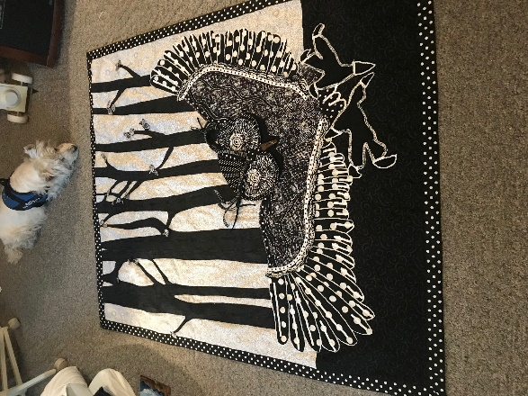

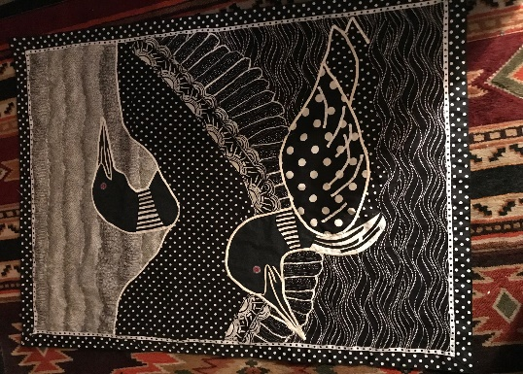**Two**

**quilts**

**made by Mary Lou Oslund**

**Hal** with his tomato plants in Rockwood’s garden-plot area; Claudia planting geraniums in front yard.

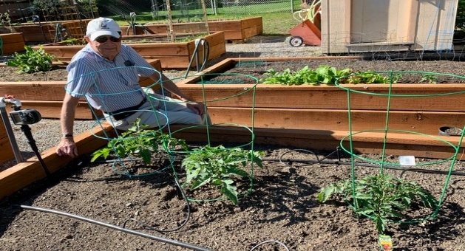

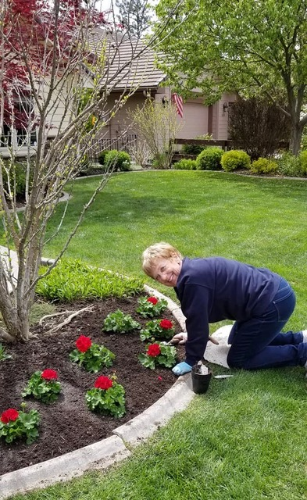

**Judy Burry** suggests “HeartLand” as good viewing on Netflix

**From Marianne Clarke:** So many of my thoughts are with my children. Son Tom is newly remarried and living in Annapolis, MD. His wedding followed COVID rules, just ten people attending. Daughter Beth remains in Taipei, Taiwan, for the unforeseeable future. I am deeply grateful for my son’s happiness and my daughter’s safety. I look forward to the time when we can be together for a family celebration.

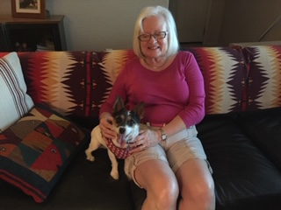

**Nancy O’Neal** “Two Couch Potatoes”

(just perfect for the 4th! MW)

**Maxine Walker** found *Bel Canto*  a good read. Anne Patchett

**Keith Walker** is reading *How We Live* by Sherwin B. Nuland.

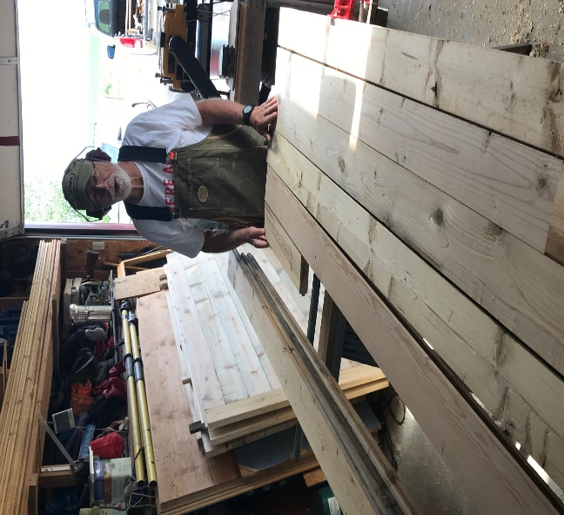**Pete Oslund** in his workshop making tables for his daughter’s Event Center.

**From Lillian Roodveldt:**  Andrew and Kara have been working out of the house all these months.  Kara is now on summer holidays which she so much needs as being a music and choir teacher during the pandemic and having to do zooming with her students was very stressful but she did wonderful things, all on line.

Andrew has also been working from the house but this past week the bank has them working one week at the office in Phoenix and one week at home which doesn't make me very happy, given the way things are in AZ. But they are both very careful and staying home and doing all that needs to be done to stay protected.

I feel I am under house arrest!  at the beginning of the month I had my three month meeting on line with my endocrinologist and she was so strict and doesn't want me to do practically anything outside the house, other than going for walks, which with this heat is totally impossible! and I can get together with Andrew and Kara and her parents as we are all being very careful and looking after ourselves.

My social activity is now hours and hours on Zoom, I do Coffee hour with Dorian on Sundays and Dialogue with Scripture on Mondays, she is trying so hard to keep us connected.

* **The pandemic has also allowed me to reconnect with Eddie's (and my) Rotary club in California and I enjoy that very much, to the point they have asked me to be a guest speaker  next month which has made me very happy, I will be talking about our Youth Exchange years.**

I also do zooming with my high school friends in Argentina and that is as if we had never stopped being together, the same crazy teenagers of more than fifty years ago!!!! My lovely relatives in the UK and New Zealand are also slowly coming into the 21st century and using technology to connect, so I spend time chatting with them as well as my usual almost daily connections with June and her daughters.

As you can see, I am trying to stay active, I love my home and always have projects to do, but I do miss the freedom of going out, even if it is just to Walmart!!!!!  I do Sprouts delivery which is working very well, and the kids also get me whatever I need so that is good.

From **Barbara Ells:**

1. I enjoy having more “unprogrammed” time, but find a little programming is good. I walk (social distancing) with neighbors every morning (except Sunday) and play cribbage every evening at
2. I am glad I like to cook but going to the store only once a week is a bit challenging. I must admit I have gone twice this week.
3. I have gone through several of my recipe cookbooks and have cooked some things I have not done in a long time. Many cookbooks are now boxed up for the rummage sale.
4. I have been in contact with friends I have not seen in a long time. We have attended birthday parties via zoom and have also gotten together with family. Today’s technology has been a big help. Just think if we had to write letters and take film to be developed!
5. I have been reading more. I just finished *Angels In the Darkness* and would highly recommend it. Also, anything by Lisa See.
6. At the start of the “stay at home” I put together a list of projects to do (deleting old emails is one of them). Last time I looked; most had not been checked off. See #3,4,&5 above
7. We have tried doing a Saturday late afternoon movie time with popcorn. We watched “Miss Sloane on Prime” (excellent) and “Resistance.” Am looking for other suggestions as need an excuse for popcorn!
8. Masks are the right way to go, but I miss seeing people smile!
9. Most of all I many grateful for the many blessings I have, including all of you.

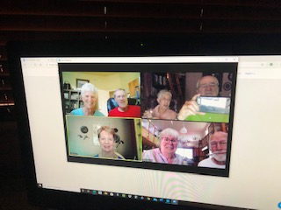**Seasoned Saints Zoom Happy Hour with a Twist:** For a couple of years one of our monthly events was *Happy Hour with a Twist* with small groups in peoples’ homes. The” twist’ was that you did not know whose house you would go to or who would be there! Someday we will be able to do that again, but for now have a new “twist”. We will be having small groups 6 – 8 people for *Zoom Happy Hour*. We had our first one on the 2nd, and everyone agreed it was great to see each other and catch up. The comments afterwards were “the highlight of my day”!

You are all invited to join in for a Happy Hour. See invite below. Right now we will do it on Thursdays at 5:00, but if that date does not work for some, we can always make adjustments. Each week we will mix up the groups so that you will be with different people – depending on who all is participating. You will receive your Zoom invitation for the Happy Hour you will be attending the day before. This will be a great way for us all to check in with each other – and be envious of those reporting in from cooler places. We look forward to “seeing you”!

**Zoom Happy Hour with a Twist** 

Thursdays 5:00

RSVP to Barbara Ells [brdrells@gmail.com](mailto:brdrells@gmail.com)

For those new to zoom, training will be available.

Photo above is from a trial zoom happy hour!

**From Renz Edwards**

I am locked in a retirement home1 block away from Melody. My family has fixed up my man cave with pictures and videos that play all the time. There have been no virus complications here. I enjoy Sunday service on the phone. Grandson Shane is here 6 days for 2 hours daily. Family facetime almost daily. . . miss all our friends but doing well thanx to you all.

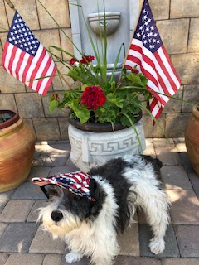

HAPPY 4th of JULY --- Misha Walker