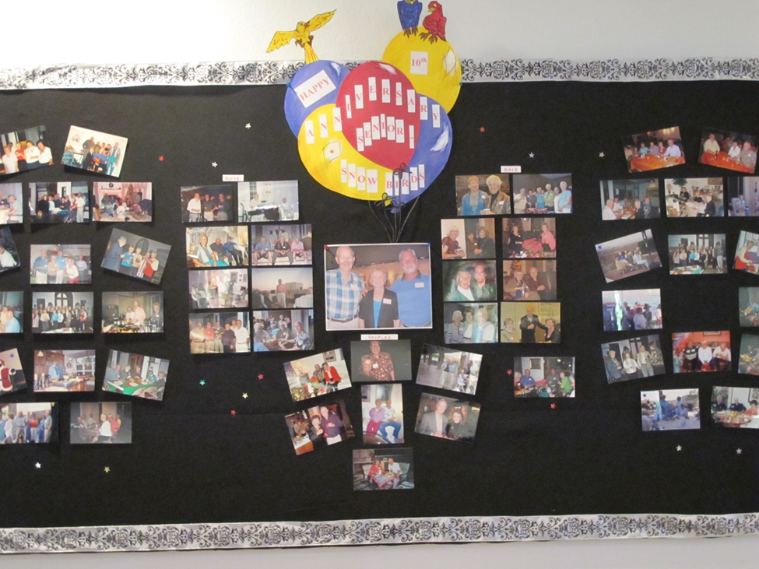

The Seasoned Saints (originally The Winter Residents) initially started in 2001 as a means for the Winter Residents to connect with each other.  Since then, we have expanded to include all Seniors of the parish (at whatever age!) and rebranded as *Seasoned Saints* a few years ago as a more inclusive name.

We have gathered – usually monthly during the “snowbird” season, for fellowship, fun, food and service.  We have supported each other in many ways.  Our social gatherings were either in the parish hall, homes, or other locations such as city parks, restaurants, or dinner theater.  We have also had many cultural events as well as service projects, and a mix of evening and daytime activities. Events are planned and organized by 2 or 3 people with email support by Maxine Walker and help as needed with bulletin announcements and signup sheets.  It has been a wonderful way for newcomers of the parish to connect with others and for all to celebrate our love for Christ by reaching out to each other.  Our attendance can range from 10 – 50!

During the pandemic, our get -togethers were abruptly halted.  But we soon realized that we could still gather via Zoom. Over the past 2+ years some have gathered via zoom which has been a great way to stay connected.  However, not all comfortable with Zoom, and it certainly is different from being together.

Now that we can gather in person, we will put our Zoom gatherings on hiatus.  It may still be nice to stay connected during the summer months. Our October event was a Happy Hour gathering in the parish hall, and while many of our snowbirds weren’t back yet, it was nice to welcome some new parishioners who haven’t joined us before.

Snowbirds Events from the past (but we would love new ideas!)

1.     Potluck dinners in Parish Hall – with or without themes.  
 - Memories  
 - game night

 - wine tasting

2.     Potluck dinner in peoples’ homes  
 - Christmas dinners (lately with bus service!)  
 - Fall and spring dinners  
 - Whenever dinner!

3.     Appetizer and Dessert gathering (who needs anything else!)

4.     Late Nite Catechism theatre followed by Pizza dinner

5.     Barleen’s Dinner show in Apache Junction

6.     Mesa dinner theatre

7.     Happy Hour at Vito’s

8.     Happy Hour with a Twist (small groups in several homes)

9.     Starfire Golf Club Sunday brunch

10.  Brunch in homes after church on Sunday

11.  Brunch at Eagle Mountain

12.  Free Symphony Concert at Scottsdale Bible Church followed by optional dinner out

13.  Wine and appetizers in someone’s home before a play at Desert Stages Theatre

14.  Picnic in the Park (Scottsdale Ranch Park) – grilled hot dogs, etc.

15.  Trip to Basha’s Western Art Gallery and lunch

16.   Trip to Western Art Museum and optional lunch

17.  Culinary Art institute lunch

18.  Habitat Build

19.  Serving dinner to the men at the East Valley men’s shelter

20. “Mock’ Tailgate party (tailgate food, team colors, etc.)

21.  Desert Botanical Garden Chihuly exhibit and lunch

22.  Musical Instrument Museum tour and lunch

23.  10-year anniversary party (2011) – catered dinner in parish hall

24.  Boat ride on the lake

25.  Reserving tables and supporting the charity Golf Tournament